Rest Assured | 65 | Interview question | How to get the request specification properties

In this video, we will learn how to get the properties set to the request specification.
public void Createemployee() {

RestAssured.baseURI = "http://localhost:3000/";

RequestSpecification requestspecification = RestAssured.given().
header("Content-Type","application/json").
body("{\r\n"
+ "\"first_name\": \"Krish\",\r\n"
+ "\"last_name\": \"vanth\",\r\n"
+ "\"email\": \"Krish@gmail.com\"\r\n"
+ "}\r\n"
+ " ");

Response response = requestspecification.request(Method.POST, "employees");
}
In above code , we need to get th header details,base url used, method used..by suing
QueryableRequestSpecification specquery = SpecificationQuerier.query(requestspecification);
SpecificationQuerier is a class, query is a method & return type is QueryableRequestSpecification
package restassured_nonbdd;

import org.testng.annotations.Test;

import io.restassured.RestAssured;
import io.restassured.http.Method;
import io.restassured.response.Response;
import io.restassured.specification.QueryableRequestSpecification;
import io.restassured.specification.RequestSpecification;
import io.restassured.specification.SpecificationQuerier;

public class Getspecificationproperties {

@Test
public void Createemployee() {

RestAssured.baseURI = "http://localhost:3000/";

RequestSpecification requestspecification = RestAssured.given().
header("Content-Type","application/json").
body("{\r\n"
+ "\"first_name\": \"Krish\",\r\n"
+ "\"last_name\": \"vanth\",\r\n"
+ "\"email\": \"Krish@gmail.com\"\r\n"
+ "}\r\n"
+ " ");

Response response = requestspecification.request(Method.POST, "employees");

//need to use asPrettyString, it will provide the response in align way/proper
QueryableRequestSpecification specquery = SpecificationQuerier.query(requestspecification);

System.out.println(specquery.getBaseUri());
System.out.println(specquery.getHeaders());
System.out.println(specquery.getMethod());

}

}

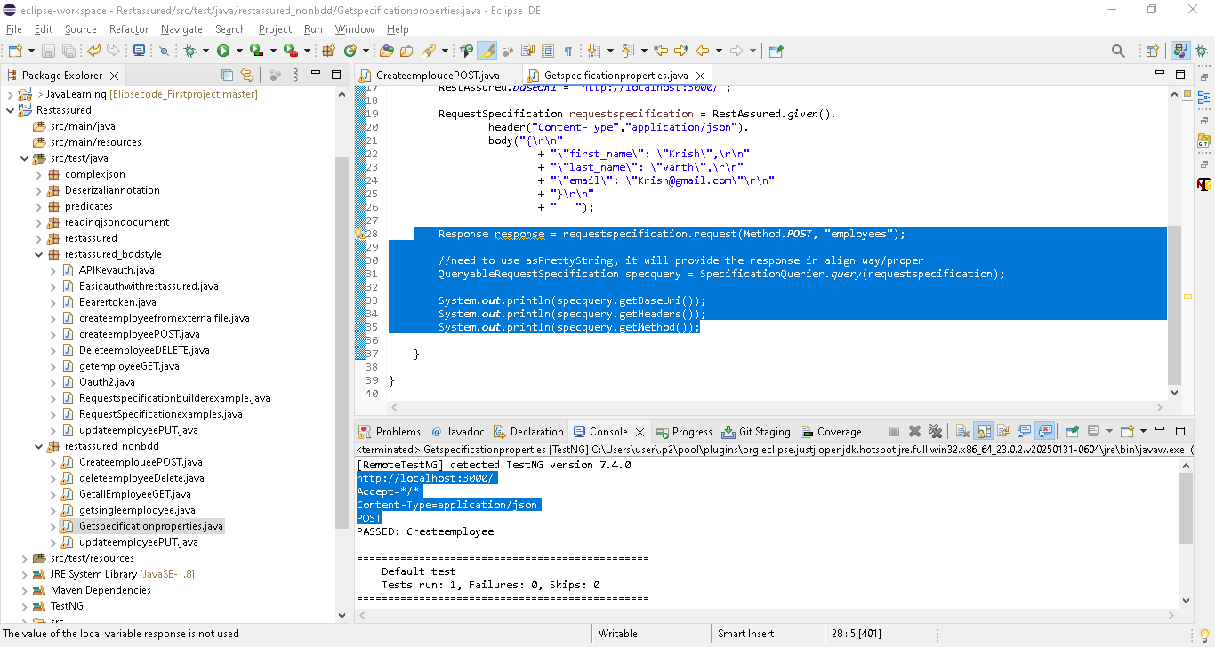

Rest Assured | 66 | Interview question | Predict the output of the code |

package restassured_bddstyle;

import static io.restassured.RestAssured.given;

import org.testng.annotations.Test;
public class defaultbaseurlexample {

@Test
public void getemployee() {

given()
.log()
.all()
.when()
.get();

}

}
In above code, no base url given, execute and check the result

By default if no base url given then it will hit the Request URI: http://localhost:8080/ by default in API
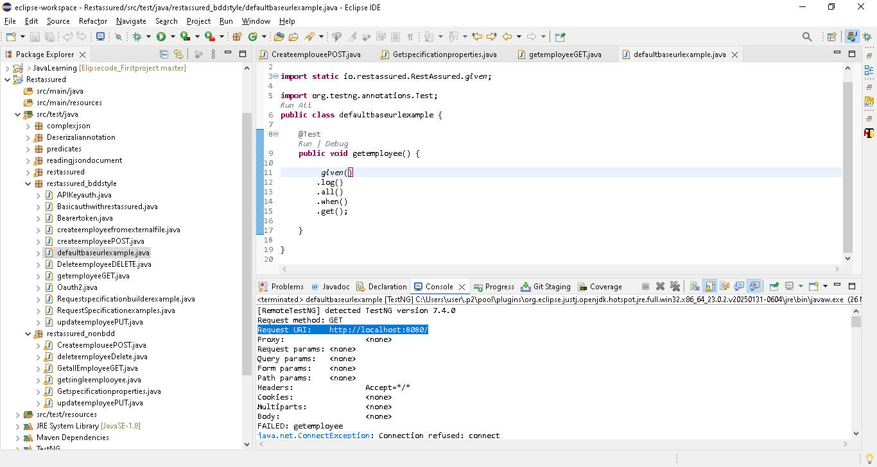
And also throw connection exception
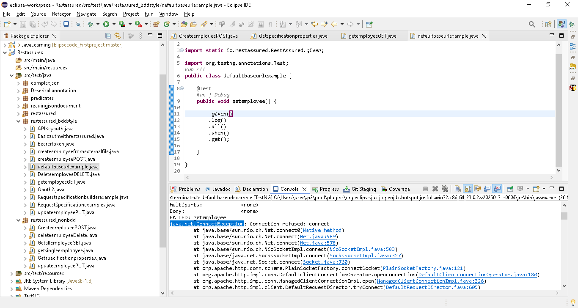
Note: .log() & .all() it will show all below in output

Request method: GET
Request URI: http://localhost:8080/
Proxy: <none>
Request params: <none>
Query params: <none>
Form params: <none>
Path params: <none>
Headers: Accept=*/*
Cookies: <none>
Multiparts: <none>
Body: <none>
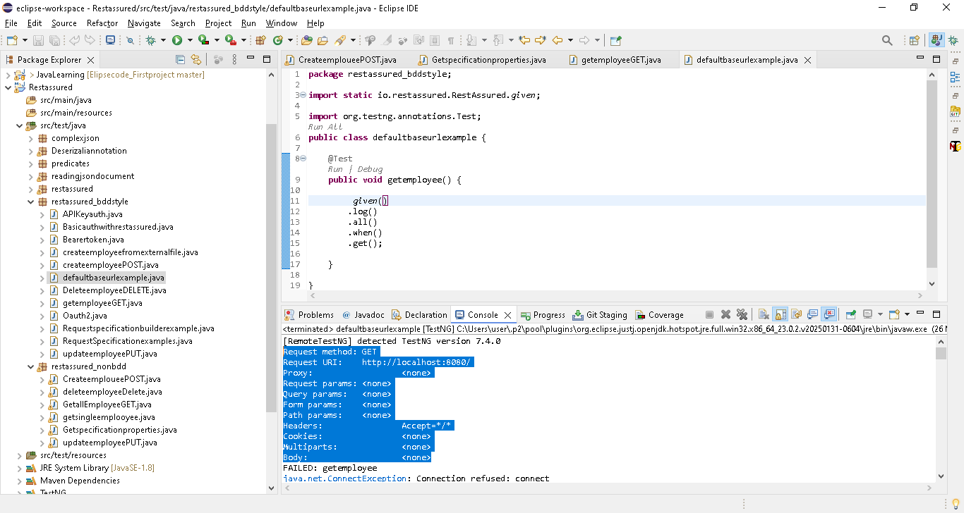

Rest Assured | 67 | Interview question | How to compare Two json files |

By using jsontree, we can compare 2 json
package restassured_nonbdd;

import com.fasterxml.jackson.core.JsonProcessingException;
import com.fasterxml.jackson.databind.JsonMappingException;
import com.fasterxml.jackson.databind.JsonNode;
import com.fasterxml.jackson.databind.ObjectMapper;

public class Compare2json {

static String json1 ="{\r\n"
+ " \"id\": \"1\",\r\n"
+ " \"first_name\": \"Agni\",\r\n"
+ " \"last_name\": \"Prasath\",\r\n"
+ " \"email\": \"Agni@gmail.com\"\r\n"
+ " }";

static String json2 ="{\r\n"
+ " \"id\": \"1\",\r\n"
+ " \"first_name\": \"Agni\",\r\n"
+ " \"last_name\": \"Prasath\",\r\n"
+ " \"email\": \"Agni@gmail.com\"\r\n"
+ " }";

public static void main(String[] args) throws JsonMappingException, JsonProcessingException {
// TODO Auto-generated method stub

ObjectMapper mapper = new ObjectMapper();
JsonNode jsonnode1 = mapper.readTree(json1);
JsonNode jsonnode2 = mapper.readTree(json2);

System.out.println(jsonnode1.equals(jsonnode2));
}

}

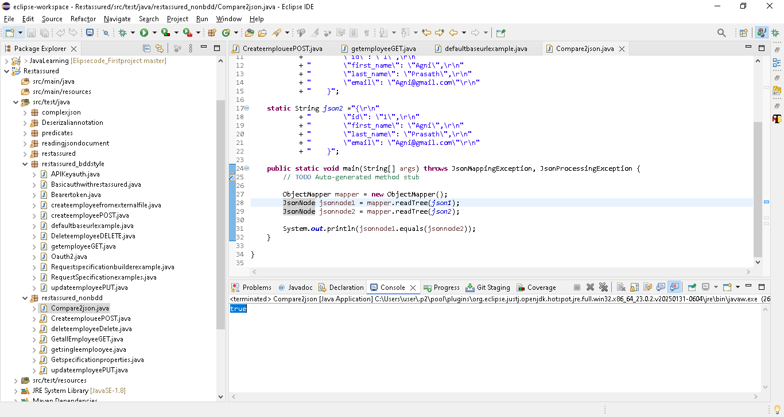
In json1, i have changed the order[firstname & lastname] & execute ->true
So even we changed the order in the dictionary tag,,it wil pass
Note: if we change inside in array list, then it will show compare fail..
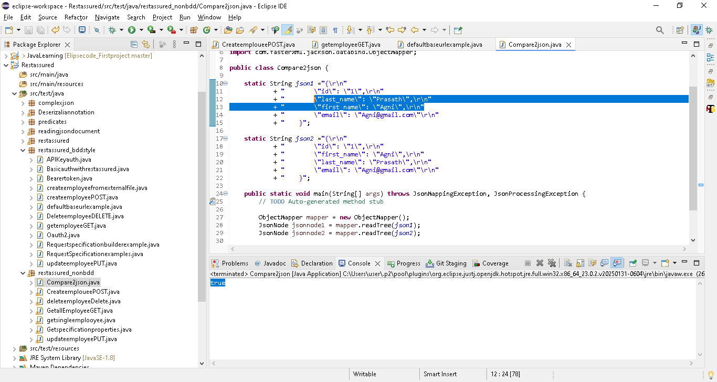
Now change the ID value & check
